**CHAPTER II**

**REPORT PROPER**

This chapter is composed of the report proper and design calculations considered in the proposed 500 MW Coal-Fired Power Plant. The methods and data are also discussed in this chapter. It also presents the summary of equipment used in the proposed coal-fired power plant.

**Methodology**

This chapter presents the methodology used to come up with the three design options of a power plant that can meet the electric demand of a particular location.

* 1. Choose a location of the power plant by identifying the following:

1. Topography;
2. Source of cooling water;
3. Nearness to the load center;
4. Type of land use;
5. Cost of land area;
6. Access to transportation; and
7. Other necessary factors that should be considered in the construction of a power plant.
   1. Identify the electricity demand, base and peak load in the chosen location to be used as the basis of the power plant capacity.
   2. Choose among the different types of power plant the particular design that will complement to the chosen location taking in to account both the advantages and disadvantages of each. Consider also the environmental impact, economic aspects and the likes that will possibly affect the efficiency and operation of the combined cycle power plant.
   3. Design three options and draw the corresponding schematic and T-S diagrams of each to increase the efficiency of the power plant considering the annual costs and revenue they will make for the following years.
   4. Provide all the necessary calculations to come up with work and efficiencies of turbines and other equipment required.
   5. Select the different equipment using various catalogs readily available in the internet based on the result of the calculations made and gather their specifications. List all equipment data needed for the calculations and identification.
   6. Perform basic engineering economics for power plants by calculating the fixed and operating costs of the project, depreciation, payback period, return of investment, and sensitivity analysis. Evaluate also the environmental impact by calculating the rate of emissions of the different harmful gases in the environment.

**Design Calculation**

**Plant Capacity**

For the proposed coal-fired power plant, the capacity in MW will be calculated using the peak load demand, percent reserve capacity and percent losses.

Based on Table 2.0, the distribution utilities of BATELEC I, BATELEC II, First Bay Power Corporation and Ibaan Electric Engineering Corporation has a total peak load demand of 367.05 MW in the year 2030. From the data gathered, it shows that BATELEC II has the highest peak load demand which is 247.93 MW.

Percent reserve capacity is an important factor in deciding for the capacity of a power plant because it ensures that the power plant can meet the sufficient load demand of the customers even if there are some variety of weather and environmental conditions and unexpected problems and failures. For the proposed coal-fired power plant, the proponents will have a 20% addition of the forecasted peak demand as the reserve capacity.

For the power and system losses, data are gathered from the Department of Energy Distribution Development Plan and calculating for the average percent losses of the four distribution utilities, the percent losses is equivalent to 11.35%.

Calculating for the Plant Capacity using the factors stated above:

**Plant Design Options**

The design options for the proposed power plant operate with a reheat regenerative rankine cycle. The diagram of each design is shown below.

**Design Option 1**

The schematic and T-S diagram of design option 1 are shown as follows:

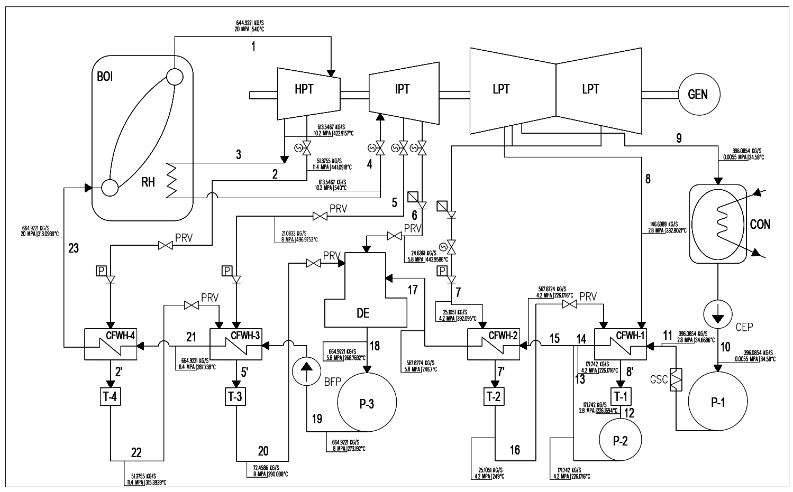

**Figure 4.** Schematic Diagram of Design Option 1

Design option 1 consists of 5 regenerative processes with 1 open feed water heater and 4 closed feed water heater. The design option has a thermal efficiency of 33.68 %.

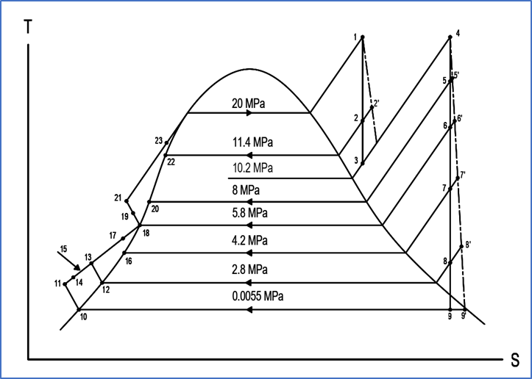

**Figure 5.** T-S Diagram of Design Option 1

The figure above shows the thermodynamic relationship within the design. The cycle consists of 23 state points with 8 operating pressures.

**Design Option 2**

The schematic and T-S diagram of design option 2 are shown as follows:

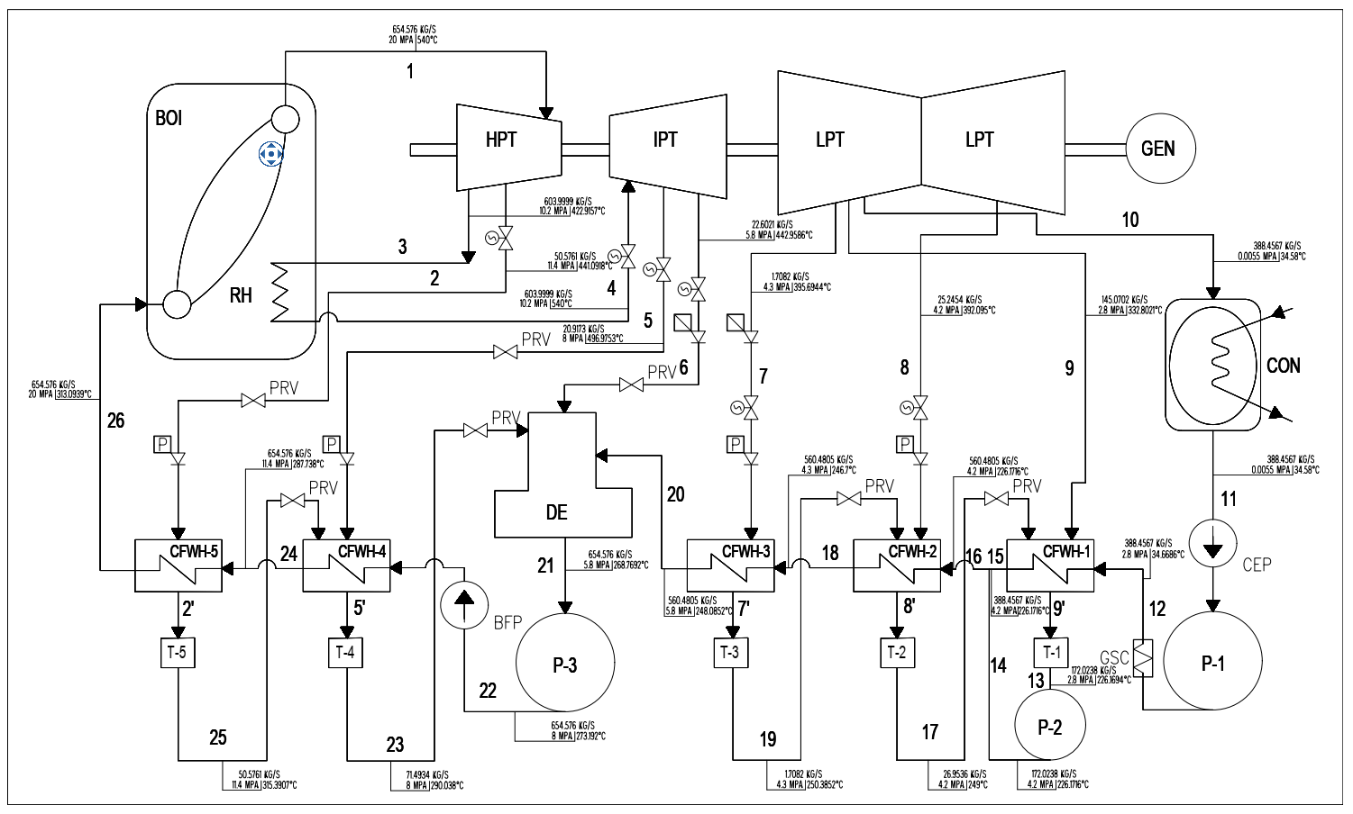

**Figure 6.** Schematic Diagram of Design Option 2

Design option 2 consists of 6 regenerative processes with 1 open feed water heater and 5 closed feed water heater. The design option has a thermal efficiency of 34.21 %.

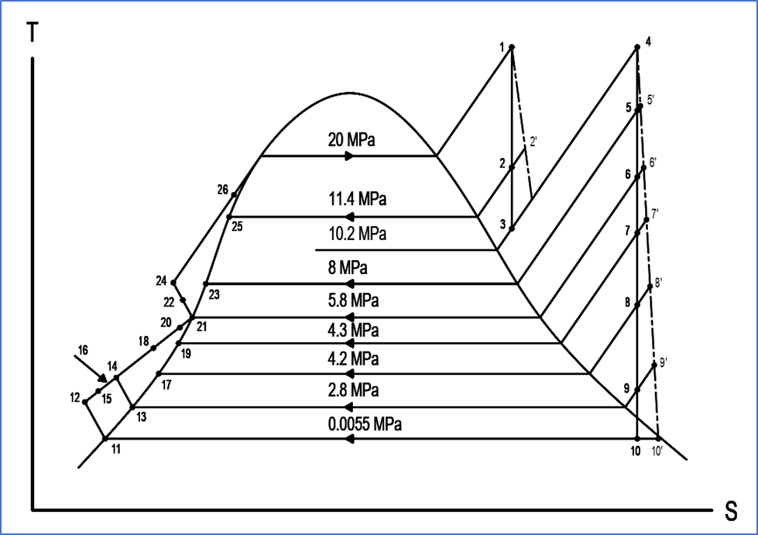

**Figure 7.** T-S Diagram of Design Option 2

The figure above shows the thermodynamic relationship within the design. The cycle consists of 26 state points with 9 operating pressures.

**Design Option 3**

The schematic and T-S diagram of design option 3 are shown as follows:

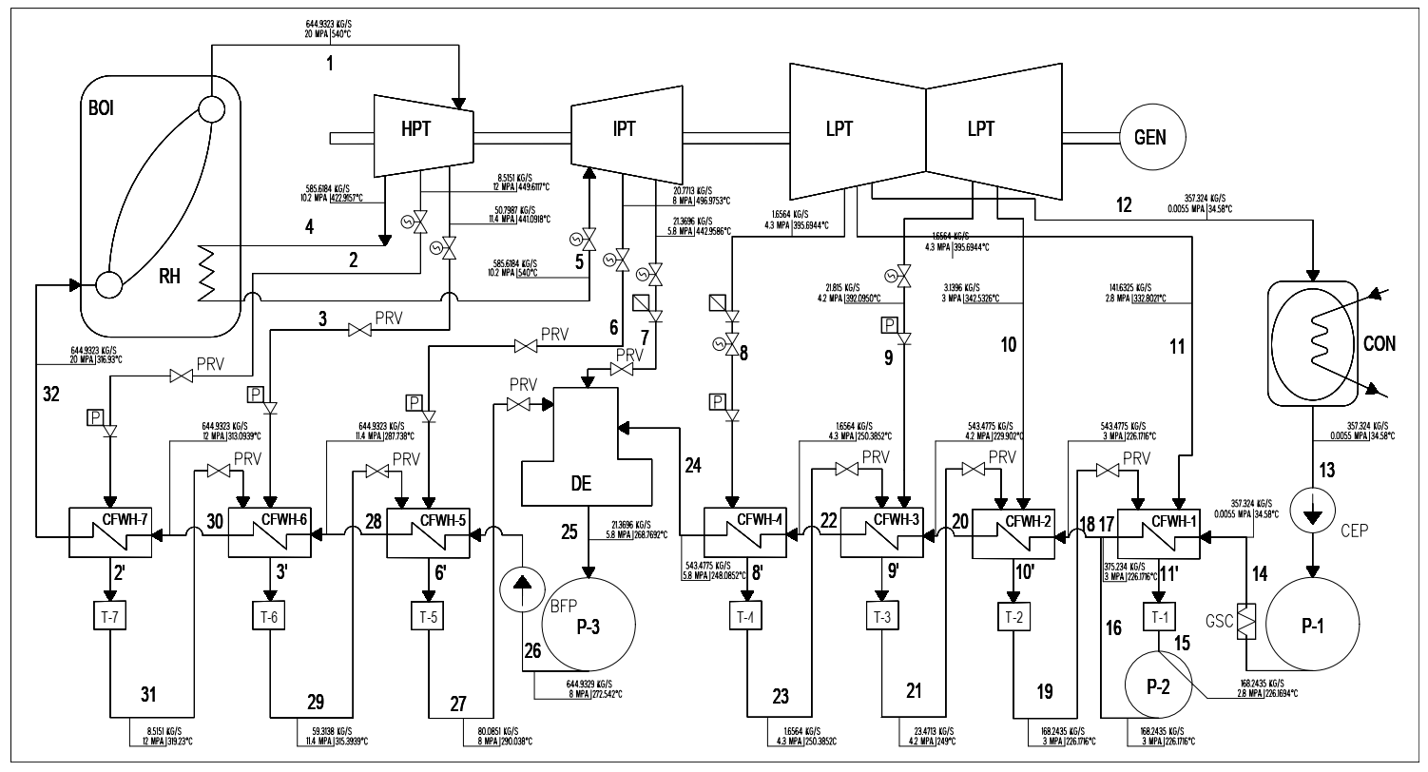

**Figure 8.** Schematic Diagram of Design Option 3

Design option 3 consists of 8 regenerative processes with 1 open feed water heater and 7 closed feed water heater. The design option has a thermal efficiency of 35.08 %.

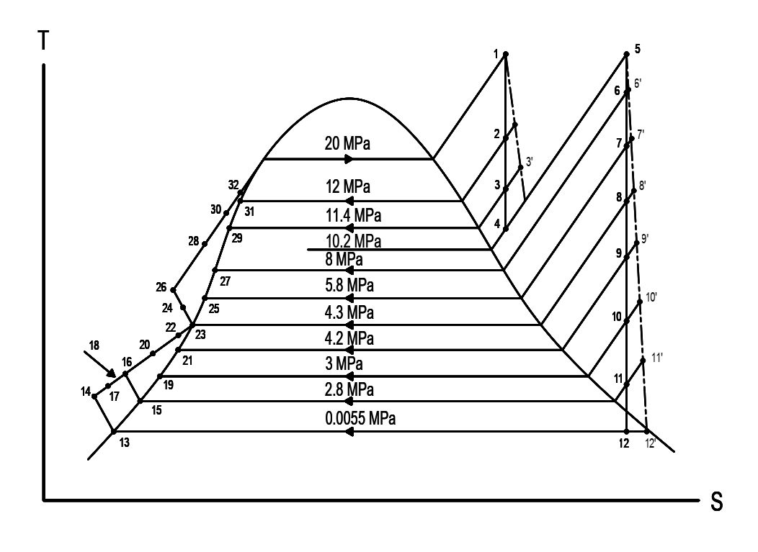

**Figure 9.** T-S Diagram of Design Option 3

The figure above shows the thermodynamic relationship within the design. The cycle consists of 32 state points with 11 operating pressures.

**Design Data**

The design data includes the ambient conditions such as pressure, humidity and temperature of the proposed location for the steam power plant in Brgy. Lumaniag, Lian, Batangas.

**Table 3.0**

**Ambient Condition in Brgy. Lumaniag, Lian, Batangas**

|  |  |  |
| --- | --- | --- |
| **Pressure** | **mbar** | **1013.0** |
| Humidity | % | 77 |
| Temperature |  | |
| Design Temperature | °C | 28 |
| Max. Temperature | °C | 36 |
| Min. Temperature | °C | 22 |

Table 3.0 shows the surrounding weather conditions in the proposed location at Brgy. Lumaniag, Lian, Batangas. The atmospheric pressure is 1013 mbar and the air has a relative humidity of 77 %. For the temperature of the location, the chosen design temperature is 28 °C as the maximum and minimum temperatures are 36 °C and 22 °C respectively.

The table below presents the operating parameters of the proposed coal-fired power plant including the efficiencies of several equipment.

**Table 4.0**

**System Operating Parameters**

|  |  |  |  |
| --- | --- | --- | --- |
| **Parameters** | **Symbol** | **Value** | **Units** |
| Fuel Higher Heating Value (actual) | HHVactual | 19,384.94 | kJ.kg |
| Boiler Efficiency | nb | 86.23 | % |
| Turbine Effciency | nt | 49 | % |
| Generator Efficiency | ng | 98.9 | % |

Table 4.0 presents the system operating parameters such as the efficiencies and fuel higher heating value necessary for the design calculations. Boiler efficiency was calculated by considering various losses while the equipment is in operation. The fuel higher heating value was calculated using the ultimate analysis of sub-bituminous coal.

The table below shows the steam cycle operating conditions of design option 1 that were used in the calculations of parameters.

**Table 5.0**

**Steam Cycle Operating Conditions for Design Option 1**

|  |  |  |
| --- | --- | --- |
| **Parameters** | **Design Option 1** | **Units** |
| High Pressure Turbine | | |
| Throttle Inlet Pressure | 20 | MPa |
| Throttle Inlet Temperature | 540 | °C |
| First Extraction Pressure | 11.4 | MPa |
| Reheat Pressure | 10.2 | MPa |
| Reheat Temperature | 540 | °C |
| Intermediate Pressure Turbine | | |
| Second Extraction Pressure | 8 | MPa |
| Third Extraction Pressure | 5.8 | MPa |
| Low Pressure Turbine | | |
| Fourth Extraction Pressure | 4.2 | MPa |
| Fifth Extraction Pressure | 2.8 | MPa |
| Condenser | | |
| Turbine Exhaust | 0.0055 | MPa |

The table above shows that for design option 1, there are five extraction pressures in the steam turbine and another for the condenser. The inlet pressure of the design option is 20 MPa and the condenser pressure is 0.0055 MPa.

The table below presents the steam cycle operating conditions for design option 2.

**Table 6.0**

**Steam Cycle Operating Conditions for Design Option 2**

|  |  |  |
| --- | --- | --- |
| **Parameters** | **Design Option 2** | **Units** |
| High Pressure Turbine | | |
| Throttle Inlet Pressure | 20 | MPa |
| Throttle Inlet Temperature | 540 | °C |
| First Extraction Pressure | 11.4 | MPa |
| Reheat Pressure | 10.2 | MPa |
| Reheat Temperature | 540 | °C |
| Intermediate Pressure Turbine | | |
| Second Extraction Pressure | 8 | MPa |
| Third Extraction Pressure | 5.8 | MPa |
| Low Pressure Turbine | | |
| Fourth Extraction Pressure | 4.3 | MPa |
| Fifth Extraction Pressure | 4.2 | MPa |
| Sixth Extraction Pressure | 2.8 | MPa |
| Condenser | | |
| Turbine Exhaust | 0.0055 | MPa |

The table above shows that for design option 2, there are six extraction pressures in the steam turbine and another for the condenser. The inlet pressure of the design option is 20 MPa and the condenser pressure is 0.0055 MPa.

The table below presents the steam cycle operating conditions for design option 3.

**Table 7.0**

**Steam Cycle Operating Conditions for Design Option 3**

|  |  |  |
| --- | --- | --- |
| **Parameters** | **Design Option 3** | **Units** |
| High Pressure Turbine | | |
| Throttle Inlet Pressure | 20 | MPa |
| Throttle Inlet Temperature | 540 | °C |
| First Extraction Pressure | 12 | MPa |
| Second Extraction Pressure | 11.4 | MPa |
| Reheat Pressure | 10.2 | MPa |
| Reheat Temperature | 540 | °C |
| Intermediate Pressure Turbine | | |
| Third Extraction Pressure | 8 | MPa |
| Fourth Extraction Pressure | 5.8 |  |
| Low Pressure Turbine | | |
| Fifth Extraction Pressure | 4.3 | MPa |
| Sixth Extraction Pressure | 4.2 | MPa |
| Seventh Extraction Pressure | 3 | MPa |
| Eight Extraction Pressure | 2.8 | MPa |
| Condenser | | |
| Turbine Exhaust | 0.0055 | MPa |

The table above shows that for design option 3, there are eight extraction pressures in the steam turbine and another one for the condenser. The inlet pressure of the design option is 20 MPa and the condenser pressure is 0.0055 MPa.

**Design Calculation**

The design calculation enlists the calculations used in obtaining the mass of flow rate of steam, total heat added, heat loss, steam turbine work, pump work, net cycle work, thermal efficiency and steam rate.

**Table 8.0**

**Summary of Calculation for Design Option 1**

|  |  |  |  |  |
| --- | --- | --- | --- | --- |
|  | **Equation** | **Symbol** | **Value** | **Units** |
| Mass flow rate of steam | ms = Pout/Wnet | ms | 664.92 | kg/s |
| Heat added in the boiler | Qb = ms(h1-h23) | Qb | 1,292,566.46 | kW |
| Heat added in the reheater | Qrh = (m1-m2)(h4-h3) | Qrh | 191,883.39 | kW |
| Heat Loss | Ql = (m23-m2-m5-m6-m7-m8)(h9a-h10) | Ql | 984,449.85 | kW |
| Turbine Work | WT = m23(h1-h2a) + (m23-m2)(h2a-h3) + (m23-m2)(h4-h5a) + (m23-m2-m5)(h5a-h6a) + (m23-m2-m5-m6)(h6a-h7a) + (m23-m2-m5-m6-m7)(h7a-h8a) + (m23-m2-m5-m6-m7-m8)(h8a-h9a) | Wt | 514,083.00 | kW |
|
|
|
| Pump Work | WP = (h11 - h10) + (h13-h12) + (h19-h18) | WP | 14,843.58 | kW |
| Total Heat Added | Qa = Qb + Qrh | Qa | 1,484,449.85 | kW |
| Net Cycle Work | Wnet = Qa - Ql | Wnet | 500,000 | kW |
| Thermal Efficiency | eth = Wnet/Qa | eth | 33.68 | % |
| Steam Rate | SR = 3600/Wnet | SR | 0.0072 | kg/kWh |
| Generator Output | Gen. Output = eg x Turbine Output | GO | 508,428.08 | KW |

This table shows the different parameters used to calculate the thermal efficiency of a reheat regenerative cycle for Design Option 1. The heat added and rejected of the cycle is determined by the energy balance equation for the system. Similarly, the turbine work and pump work is obtained by getting the difference of the enthalpies between the inlet and outlet of the component. The results obtained are based on the capacity of the coal fired power plant which is 500 MW. The design option 1 shows that the thermal efficiency is about 33.68%.

**Table 9.0**

**Summary of Calculation for Design Option 2**

|  |  |  |  |  |
| --- | --- | --- | --- | --- |
|  | **Equation** | **Symbol** | **Value** | **Units** |
| Mass flow rate of steam | ms = Pout/Wnet | ms | 654.58 | kg/s |
| Heat added in the boiler | Qb = ms(h1 - h26) | Qb | 1,272,454.21 | kW |
| Heat added in the reheater | Qrh = (m1 - m2)(h4 - h3) | Qrh | 188,897.70 | kW |
| Heat Loss | Ql = (m26 - m2 - m5 - m6 - m7 - m8)(h10a-h11) | Ql | 961,351.90 | kW |
| Turbine Work | WT = m26(h1-h2a) + (m26-m2)(h2a-h3) + (m26-m2)(h4-h5a) + (m26-m2-m5)(h5a-h6a) + (m26-m2-m5-m6)(h6a-h7a) + (m26-m2-m5-m6-m7)(h7a-h8a) + (m26-m2-m5-m6-m7-m8)(h8a-h9a) + (m26-m2-m5-m6-m7-m8-m9)(h9a-h10a) | WT | 513,512.02 | kW |
|
|
|
| Pump Work | Wp = (h12 - h11) + (h14-h13) + (h22-h21) | Wp | 14,264.86 | kW |
| Total Heat Added | Qa = Qb + Qrh | Qa | 1,461,351.91 | kW |
| Net Cycle Work | Wnet = Qa - Ql | Wnet | 500,000 | kW |
| Thermal Efficiency | eth = Wnet/Qa | eth | 34.21 | % |
| Steam Rate | 3600/Wnet | SR | 0.0072 | kg/kWh |
| Generator Output | Gen. Output = eg x Turbine Output | GO | 507,863.38 | kW |

This table shows the different parameters used to calculate the thermal efficiency of a reheat regenerative cycle for Design Option 2. The heat added and rejected of the cycle is determined by the energy balance equation for the system. Similarly, the turbine work and pump work is obtained by getting the difference of the enthalpies between the inlet and outlet of the component. The results obtained are based on the capacity of the coal fired power plant which is 500 MW. The design option 1 shows that the thermal efficiency is about 34.21%.

**Table 10.0**

**Summary of Calculation for Design Option 3**

|  |  |  |  |  |
| --- | --- | --- | --- | --- |
|  | **Equation** | **Symbol** | **Value** | **Units** |
| Mass flow rate of steam | ms = Pout/Wnet | ms | 646.41 | kg/s |
| Heat added in the boiler | Qb = ms(h1 - h32) | Qb | 1,241,645.93 | kW |
| Heat added in the reheater | Qrh = (m32- m2-m3)(h5 - h4) | Qrh | 183,569.25 | kW |
| Heat Loss | Ql = (m32 - m2 - m3 - m6 - m7 - m8 - m9 - m10 - m11)(h9a-h10) | Ql | 925,215.19 | kW |
| Turbine Work | WT = m32(h1-h2a) + (m32-m2)(h2a-h3a) + (m32-m2-m3)(h3a-h4) + (m32-m2-m3)(h5-h6a) + (m32-m2-m3-m6)(h6a-h7a) + (m32-m2-m3-m6-m7)(h7a-h8a) + (m32-m2-m3-m6-m7-m8)(h8a-h9a) + (m32-m2-m3-m6-m7-m8-m9)(h9a-h10a) + (m32-m2-m3-m6-m7-m8-m9-m10)(h10a-h11a) +(m32-m2-m3-m6-m7-m8-m9-m10-m11)(h11a-12a) | WT | 512,859.36 | kW |
|
|
|
| Pump Work | Wp = (h14 - h13) + (h16-h15) + (h26-h25) | Wp | 12,369.08 | kW |
| Total Heat Added | Qa = Qb + Qrh | Qa | 1,425,215.18 | kW |
| Net Cycle Work | Wnet = Qa - Ql | Wnet | 500,000 | kW |
| Thermal Efficiency | eth = Wnet/Qa | eth | 35.08 | % |
| Steam Rate | 3600/Wnet | SR | 0.0072 | kg/kWh |
| Generator Output | Gen. Output = eg x Turbine Output | GO | 507,219.90 | kW |

This table shows the different parameters used to calculate the thermal efficiency of a reheat regenerative cycle for Design Option 3. The heat added and rejected of the cycle is determined by the energy balance equation for the system. Similarly, the turbine work and pump work is obtained by getting the difference of the enthalpies between the inlet and outlet of the component. The results obtained are based on the capacity of the coal fired power plant which is 500 MW. The design option 1 shows that the thermal efficiency is about 35.08%.

**Summary of Calculation**

Table 7.0 shows the summary of calculations for Design Option 1 (4 closed feedwater heaters and 1 open feedwater heater), Design Option 2 (5 closed feedwater heaters and 1 open feedwater heater) and Design Option 3 (7 closed feedwater heaters and 1 open feedwater heater). The calculations included are the useful energy or the calculated output capacity, heat loss due to moisture in air and heat addition of the proposed steam cycle powerplant. Each value is in MW. In addition, individual efficiencies are shown in the table and the total steam turbine work of each design option.

**Table 11.0**

**Summary of Calculation for the Three Design Options**

|  |  |  |  |  |
| --- | --- | --- | --- | --- |
| **HP – System** | **Units** | **Design Option 1** | **Design Option 2** | **Design Option 3** |
| **Technical Data and Parameters** | | | | |
| Useful Energy | kJ/kg | 21817.44 | 21817.44 | 21817.44 |
| Heat Loss due to moisture in Air | MW | 984.45 | 961.35 | 925.22 |
| Heat Gained | MW | 1484.45 | 1461.35 | 1425.22 |
| Mass flow rate of steam | kg/s | 664.92 | 654.58 | 646.41 |
| Steam Rate | kg/kWh | 0.01 | 0.01 | 0.01 |
| Pump Work | MW | 14.84 | 14.26 | 12.37 |
| Thermal Efficiency | % | 33.68 | 34.21 | 35.08 |
| Steam Turbine Work | MW | 514.08 | 513.51 | 512.86 |
| **Environmental Parameters** | | | | |
| Carbon oxide emission | kg/s | 136.94 | 134.81 | 131.48 |
| Nitrogen oxide emission | kg/s | 2.25 | 2.22 | 2.16 |
| Sulfur oxide emission | kg/s | 0.99 | 0.98 | 0.95 |
| Ash Disposal | kg/s | 13.87 | 13.65 | 13.31 |

Based on the summary of calculations, design option 3 has the highest value of thermal efficiency among the three design options. Design Option 3 has a thermal efficiency of 35.08 %. Therefore, it can be concluded that design option 3 which has 7 closed feedwater heaters and 1 open feedwater heater is the best design among the three.

**Equipment Selection**

Selecting the best equipment is very important in order to have an efficient performance of a power plant by having high efficiency and longer service lives. Table 8.0 presents the comparison of Chinese, US and European equipment based on the relative cost, average efficiency, service life and maintenance costs.

**Table 12.0**

**Equipment Selection**

|  |  |  |  |  |  |  |
| --- | --- | --- | --- | --- | --- | --- |
|  | Relative Capital Cost | Php/kW | Average Efficiency | T1 years | T2 years | O&M |
| Chinese Equipment | ₱74,324,187,000.00 | 9.80 | 42 | 1 | 25 | ₱1,307,923,820.00 |
| US Equipment | ₱74,605,257,247.50 | 9.80 | 43 | 1 | 25 | ₱1,307,923,820.00 |
| European Equipment | ₱74,751,908,000.00 | 9.80 | 46 | 1 | 25 | ₱1,307,923,820.00 |

T1 – Interval of Major Maintenance

T2 – Interval between Complete Replacement

Table 8.0 shows that equipment from the three different manufacturers differs in terms of relative capital cost and average efficiency. It can be observed that the efficiency of European Equipment has the highest efficiency among the three equipment. This equipment has the same interval of major maintenance and complete replacement.

Further comparison of the given equipment will be shown in Table 9.0 which will be useful in selecting the best equipment.

**Table 13.0**

**Comparison of Given Equipment**

|  |  |  |  |  |  |  |  |
| --- | --- | --- | --- | --- | --- | --- | --- |
|  |  | Chinese Equipment | | US Equipment | | European Equipment | |
|  |  | PHP | % | PHP | % | PHP | % |
| Total equity | Php | 23,377,487,102.07 |  | 23,348,164,414.77 |  | 23,332,865,057.42 |  |
| Total loan | Php | 8,918,902,440.00 |  | 8,952,630,869.70 |  | 8,970,228,960.00 |  |
| Total capital cost | Php | 74,324,187,000.00 |  | 74,605,257,247.50 |  | 74,751,908,000.00 |  |
|  | Php/kW | 148,648.37 |  | 149,210.51 |  | 149,503.82 |  |
| Average generation | GWh | 4200 |  | 4200 |  | 4200 |  |
| DSCR, first year | [ ] | 14.55368053 |  | 14.49885052 |  | 14.4704062 |  |
| FIRR | [ ] | 344,270,287,220.86 |  | 343,989,216,973.36 |  | 343,842,566,220.86 |  |

From Table 9.0, it can be observed that the given equipment are compared based on economic aspect such as the total amount of equity, loan and capital cost. Average generation, rate of return and debt service cover ratio of the three equipment are also compared.

**Summary of Equipment**

Table 10.0 shows the specification of the equipment used in the coal-fired power plant. Some details of each component are also listed such as the tag number and selection parameter. The page number of the catalogue is also included in the table.

**Table 14.0**

**Summary of Equipment**

|  |  |  |  |  |
| --- | --- | --- | --- | --- |
| **Tag No.** | **Component** | **Selection Parameter** | **Specification** | **Page No.** |
| B- | Boiler | **Fuel:** Sub-bituminous Coal  **Pressure:** 200 bar  **Temperature:** 540 °C  **Reheat Pressure:** 102 bar  **Reheat Temperature:** 422 °C | **Model:** GE CFB Technology – Two Pass Boiler  **Typical Fuels:** Bituminous, Sub-bituminous, Lignite A, Oil and Gas  **Capacity:** up tp 1,350 MWe  **Pressure:** up to 330 bar  **Temperature:** 650 °C / 670 °C  **Reheat Pressure:** 330 bar  **Reheat Temperature:** 670 °C |  |
| ST- | Steam Turbine | **Power Output:** 500 MW  **Inlet Pressure:** 200 bar  **Inlet Temperature:** 540 °C | **Model:** GE STF-D850  **Capacity:** up to 1000 MW  **Pressure: up to** 245 bar/ 3553 psi  **Temperature:** up to 585 °C/ 1085 °F  **Reheat Temperature:** up to 585 °C/ 1085 °F |  |
| CON- | Condenser | **Pressure:** 55 mbar  **Circulating Water Temperature:** 34.58 °C | **Model:** GE Single Vacuum Type Condenser  **Condenser Thermal Load:** 1,820 MW  **Absolute Pressure:** 55 mbar  **Circulating Water Temperature:** 25 °C |  |
| CFWH- | Closed Feedwater Heater | **Low Pressure Rating:** 406-623 psig  **High Pressure Rating:** 1653-1740 psig | **Model:** Energyen SPX Heater  **Low Pressure Rating:** 400-800 psig  **High Pressure Rating:** 1600-4800 psig |  |
| DE- | Deaerator | **Mass flow rate:** | **Model:** Eurowater Deaerator  **Tank Volume:** 11,575 liters  **Steam Requirements:** 3240 kg/hr |  |
| BFP- | Boiler Feed Pump | **Pressure:** 58 bar  **Temperatue:** 268 °C  **Efficiency:** 86.23 % | **Model:** Flowserve Multistage Boiler Feedwater Pumps  **Flow:** 5220 m3/h  **Head:** 4270 m  **Pressure:** 517 bar (7500 psi)  **Temperature:** 315 °C (600 °F) |  |
| CEP- | Condensate Extraction Pump | **Pressure:** 0.055 bar  **Temperature:** 34.58 °C | **Model:** Flowserve Vertical, Multistage Condensate Extraction Pumps  **Flow:** 13,600 m3/h (60,000 gpm)  **Head:** 1070 m (3500 ft)  **Pressure:** 100 bar (1450 psi)  **Temperature:** 230 °C (450 °F) |  |
| CWP- | Circulating Water Pump | **Flow:** 180 000 m3/h  **Pressure:** up to 5 bar  **Temperature:** 30 °C | **Model:** Flowserve Vertical Circulating Water Pump  **Flow:** 181 700 m3/h  **Head:** 110 m (350 ft)  **Pressure:** 5 bar (75 psi)  **Temperature:** up to 65 °C |  |
| T- | Steam Trap | **Pressure:** 406 psig  **Temperature:** 332.80 °C | **Model: Series 460 High Pressure Steam Traps**  **Operating Pressure:** 150 – 900 psig  **Operating Temperature:** 482.22 °C (900 °F) |  |
| GEN- | Generator | **Power:**  **Efficiency:** | **Model:** Water-Cooled GIGATOP Generator  **Frequency:** 60 Hz  **Power Factor:** 0.85  **Apparent Power:** up to 1,120 MVA  **Efficiency:** up to 98.9 %  **Terminal Voltage:** up to 26 kV |  |

The table above shows the list of equipment and specifications used in the design of the proposed coal-fired power plant. Each component is named with tag numbers and has selection parameter used in the calculation of the design options.

**Equipment Description**

Each component plays an important role in a power plant to have an efficient performance. The major equipment of the proposed coal-fired power plant is briefly discussed below.

1. Steam Turbine

The steam turbine is a prime mover for the conversion of heat energy of steam into work on a revolving shaft, utilizing fluid acceleration principles in jet and vane machinery. The chosen turbine STF – D850 is manufactured by GE which consists of double-flow LP sections and a separate HP. The main inlet pressure is up to 245 bar with main steam inlet and reheat temperatures up to 585 °C. The operating capacity of the steam turbine is up to 1000 MW with steam turbine efficiency of 49%.

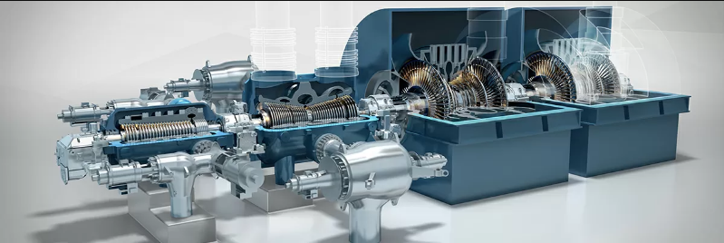

**Figure 10.** STF Turbine, GE

2. Boiler

The steam boiler is an integrated assembly of several essential components the function of which is to produce steam at a predetermined pressure and temperature. The chosen boiler design is manufactured by GE with up 1350 MW electrical for coal units. The type of fuel used is sub-bituminous coal which is suitable for the design of the boiler. Its operating pressure ranges up to 330 bar with temperature up to 650 °C.

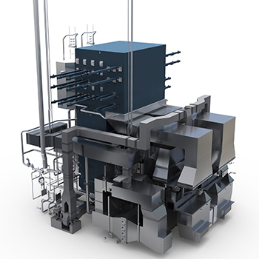

**Figure 11.** Two Pass Boiler, GE

3. Condenser

The proposed power plant used a condenser equipment from 2017 Steam Power Systems Product Catalog or GE Single Vacuum Type Condenser having a pressure of 55 mbar and a thermal load of 1820 MW. The circulating water temperature that will flow is 30 °C up to 33 °C with a flow of 50 m3/s and a tube length of 16.5 meters.

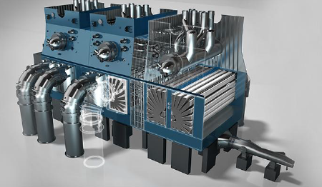

**Figure 12.** Condenser, GE

4. Closed Feedwater Heater

The closed feed water heater that will be used in the proposed power plant is Energyen SPX Heater that can be installed in both low and high pressure. The pressure ratings of the equipment have a range of 400-800 psig. It is acceptable for the design since the pressure of each design that was set is all within the range of the equipment from Energyen.

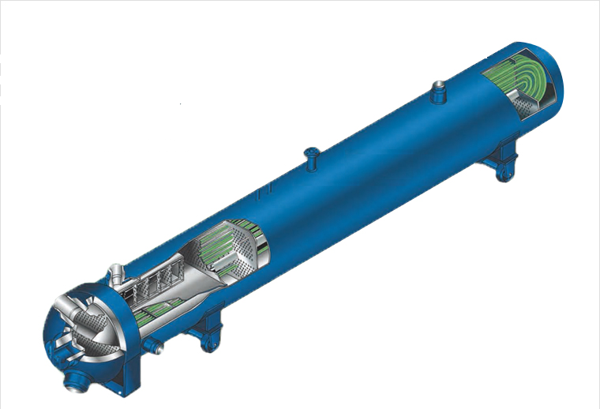

**Figure 13.** SPX Heater, Energyen

5. Deaerator

The deaerator that will be used for the proposed power plant is from Eurowater that has a tank volume of 11,575 liters. The steam requirements that will pass through the open feed water heater or the deaerator is 3240 kg/hr.

6. Boiler Feed Water Pump

The boiler feed pump that will be installed in the proposed coal-fired power plant is from FLOWSERVE. This pump can deliver a maximum flowrate of 1.45 m3/s with a head up to 4270 m. The boiler feed pump can hold a temperature limit of 315 °C.

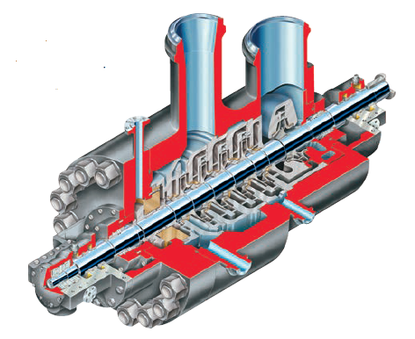

**Figure 14.** Boiler Feedwater Pump, FLOWSERVE

7. Condensate Extraction Pump

The CEP or condensate extraction pump is used to do the initial part that draws the condensate under vacuum from the condenser hot well with some positive pressure at the discharge. The pump that will be installed in the proposed coal-fired power plant is from FLOWSERVE. It has a maximum a maximum flowrate of 3.778 m3/s with a head up to 1070 m which is designed for continuous plant operations.

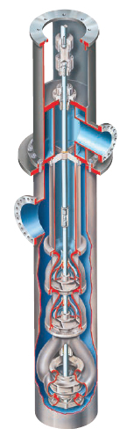

**Figure 15.** Condensate Extraction Pump, FLOWSERVE

8. Circulating Water Pump

The water that will be used as cooling water is from Nasugbu Bay then pumped through the tubes in condenser to remove the heat of vaporization from steam exiting the turbine. The circulating water pump has an operational flow rate of 50 m3/s with a head of 110 m. The selected design is a vertical wel-pit pump suitable for extended operation in condenser cooling water service.

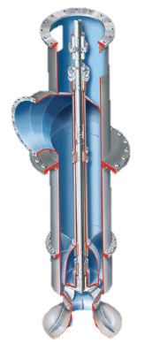

**Figure 16.** Circulating Water Pump, FLOWSERVE

9. Steam Trap

To remove the condensate from the closed feedwater heater, steam traps are used. The steam traps that will be installed in the proposed power plang is from EMERSON which is Seies 460. This is operating with a minimum and maximum pressure of 150 psig and 900 psig respectively. The maximum operating temperature of the steam trap is 900 °F.

10. Drip Pump

After the feedwater heater, the extracted steam will be converted into drip which is pumped by the drip pump back to the previous reheater. Drip goes in opposite direction of feedwater. The extracted steam rejects heat in Low Pressure Feedwater Heater 3 then drip will go to Low Pressure Feedwater Heater 2 because the temperature or enthalpy of drip in Heater 3 is more that Heater 2.

11. Generator

The generator that will be installed in the proposed coal-fired power plant is from Water Cooled GIGATOP Generator with an apparent power of 1,120 MVA. The equipment chose has 60 Hz and a power factor of 0.85. The efficiency of the water-cooled generator is up to 98.9% and the terminal voltage is up to 26 kV.

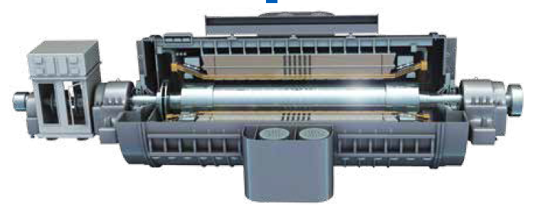

**Figure 18.** Water-Cooled Generator, GIGATOP

12. Pulveriser

After the coal has been transported from Caluya, Antique. It will be prepared in the pulveriser for higher combustion efficiency. There will be a hopper that will transfer the coal to the pulveriser until it reached the boiler through the feeder. The pulverized coal will be transported to the feeder for combustion

13. Chimney

The exhaust gases or smoke produced by boiler is exhausted in the chimney. These exhaust gases are referred as flue gas which are discharged to the atmosphere at such a height that the pollutants are kept within acceptable limits at ground level. For coal-fired power plants, flue gas is typically at about 120 °C. For the system, Natural Draught will be used as the proposed power plant will be using a chimney. For units with a capacity of 500 MW, flues are about 200 m high and 6 m in diameter.

**Process/ Schematic/ System Diagram**

1. Fuel System

The fuel system of a power plant provides and prepares the fuel for burning in the combustor. The proposed power plant will be using a sub-bituminous coal which is widely used in generating steam power and industrial purposes. It contains less sulfur but more moisture approximately 10 to 45 percent than other bituminous coal types. Sub-bituminous coal produces ash that has higher alkaline content than other coal ash that can help reduce acid rain typically caused by coal-fired power plant emissions.

Fuel of the power plant will be produced by Semirara Mining and Power Corporation which owns and mines its own fuel source (coal). The corporation produces sub-bituminous coal that is appropriate for use in a wide range of combustion facilities.

2. Transport System

The proposed power plant will use a sub-bituminous coal which will be produced by Semirara Mining and Power Corporation. Coal will be shipped to the port area where it will be conveyed in the coal storage for future use. It is important to consider the transport system for it has a part in the investment costs which is the transport cost. Available rod will also be considered for easy transportation which is one of the parameters in choosing the best location for the proposed power plant.

Semirara Mining and Power Corporation is located at Caluya, Antique which is more than 300 km from Lian, Batangas.



**Figure 19.** Transport System

3. Exhaust System

The inlet and exhaust pressures and inlet temperature of the steam in a steam engine determine the potential energy required at the turbine inlet. Water moves over an alternating series of fixed and rotating blades to release the energy inside the turbine and as a result extends from high pressure to low pressure.

The HRSG absorbs heat from the exhaust gas turbine to produce steam at temperatures up to ~650 ° C, and 13–20 MPa pressure. While SC systems have been developed, the generation of heat recovery steam is most frequently applied under subcritical conditions.

4. Storage System

It is important that adequate quantity of coal should be stored. Coal storage offers protection against coal supply disruption when there is delay in coal transport or strike in coal mines. The coal may also be bought and stored for future use, if the prices are low. The amount of coal to be stored depends on the availability of storage space, transportation facilities, the amount of coal to be stored on the power station both away from and close to coal mines.

Usually coal needed for one month of power plant service is stored in the case of power plants located at a longer distance from the collieries while coal need is stored for around 15 days in the case of power plants located close to collieries. Coal storage is not desirable for longer periods as it blocks the capital and results in a loss of coal quality.

5. Instrumentation and Control System

In order for a power plant to run efficiently, it is important to consider the instrumentation and control system which plays a major role in profitable operation of a plant. This system includes the sensors that can detect the measured values and controllers which receive these values. New coal-fired power plants are built with modern and advanced systems that can help in achieving the maximum efficiency of a power plant. It can also reduce the maintenance costs through better monitoring of plant equipment condition and detect equipment malfunctions that may lead to power plant shutdown.

6. Water Treatment System

Water treatment for generating electricity is a critical process which needs a reliable technology. High purity water ensures proper steam generation system operation, and reduces blowdown frequency and boiler chemicals usage. High purity water can also protect better against erosion and equipment destruction. When the operational pressure of the power plant rise, the demands on water quality do become more stringent. The specifications are strict for the existing equipment running at Supercritical pressures. Continuous developments and changes in techniques of preserving water quality, understanding the processes of degradation and discovering new additives have resulted in a more sustainable and effective operation of the water system.

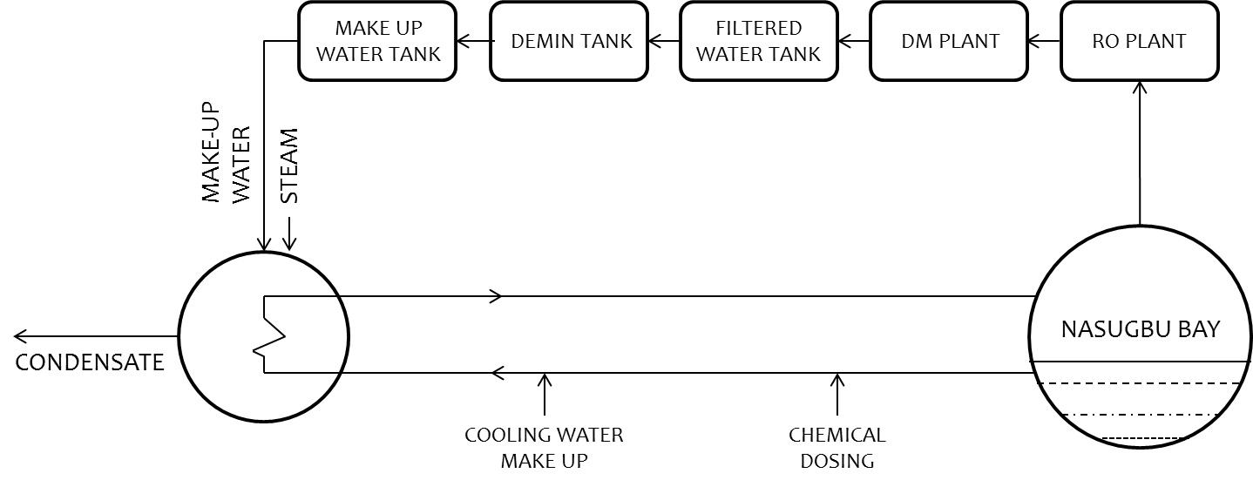

**Figure 20.** Water Treatment System Diagram

7. Cooling System

All steam power plants work by heating water in the boiler until it turns into steam. The steam is then used to spin the turbine, which then drives an attached generator, which produces electricity. Water used by the condenser to cool the steam is withdrawn from nearby rivers, lakes, and other bodies of water which are near to the plant; that is the Nasugbu Bay for the proposed design. Surrounding bodies of water is one of the parameters considered in choosing the best location for the proposed power plant for an easy access of water for the cooling system.

8. Ash Handling System

Pulverized coal burning boilers (PC) have furnaces at the bottom. Under the boiler, the large ash particles are stored in a water-filled ash hopper, Fly-ash is stored with either an electrostatic precipitator or a baghouse in dust collector. A PC boiler contains around 80% fly ash and 20% bottom ash. Ash must be collected and transported from various plant locations, as shown in figure. Pyrites, which are the pulverizer rejections, are disposed of with the ash device at the edges. Three major factors for the ash disposal systems should be considered such as, Plant sites, Fuel source and Environmental regulation. For many ash management systems needs for water and land are essential considerations. The amounts of ash to be disposed of depend on the king of fuel. Sites where ash is stored and disposed of are regulated by environmental legislation.